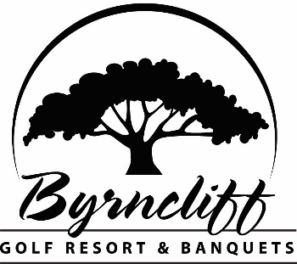
2357 Humphrey Rd. Varysburg, NY 14167
(585) 535 – 7300 www.byrncliff.com info@byrncliff.com

Extend your golf season and enjoy the beautiful fall foliage by joining the NEW Byrncliff fall golf league! To join fill out the form below and return it to Byrncliff by Sept 8th with your payment.
LEAGUE: FALL FOLIAGE
- Open to Men, Women & Couples
- Play one time per week, pick any day, Monday – Thursday
- Six consecutive weeks of fall golf
- Fun Contests and Restaurant Specials Weekly
WHEN: Official start date is the week of September 11th and end date is the week of October 16th
- Tee-times are starting at 3:30pm and will alternate weekly from front to back nine.
FORMAT: 2 Person Teams
WEEKLY RATE: The Special Fall League Rates are: $30 with a cart for 9 holes, $25 to walk, $5 for an additional 9 holes, Registration Fee: $30. Pre-payment in full is required to get these rates and due by Sept. 8th.
- Total Pre-Pay Amount including Registration Fee: $210 per person including cart, $180 per person to walk. Must use all rounds by October 19, 2023.
LEAGUE BANQUET: End of the season steak dinner on Thursday, October 19th
LEAGUES RULES:
- All league payments are non-refundable and valid only for the current season. Play one time per week, any day, Monday – Thursday starting at 3:30pm. In the event of a rain-out, league play will be extended by one week.
- The end of season banquet is Oct. 19th. If you do not participate on that day, your steak dinner will be forfeited.
--------------------------------------------------------------------------------------------------------------
Name ______________________________________ Email: _____________________________
Address: ____________________________________ Phone #:__________________________
City: ___________________________________State: _______ Zip Code: _________
Partner (each person must fill out individual form): ________________________________________
Payment: $210 per person including cart or $180 per person to walk (includes registration fee)
Cash $______________ Check # __________ (payable to Byrncliff)
Credit card # ___________________________________expires __________ CVV __________
Name on Card: ____________________________________
This application is subject to approval by Byrncliff Golf Resort & Banquets, which reserves the right to decline membership to any applicant. Byrncliff Inc. is a public serving resort. Purchasing a League membership confers no ownership rights of any kind in Byrncliff Inc. and memberships may be revoked, without compensation, for actions determined detrimental in any way to the resort. Byrncliff Golf Resort & Banquets reserves the sole rights to determine which actions are detrimental. Above discounts cannot be used with any other special promotions, discounts, golf tournaments, or overnight golf packages. I agree to pay above total amount according to card issuer agreement (merchant agreement if credit voucher). I have read the foregoing information and agree to abide by all terms and conditions listed above.

Applicant (signed)______________________________________________Date______________
For Office Use Only: Mailing List____ Sign-in Sheet_____ Master ____ Conf. Email_____ CC Ran_____GSA Initials & Date: _______

